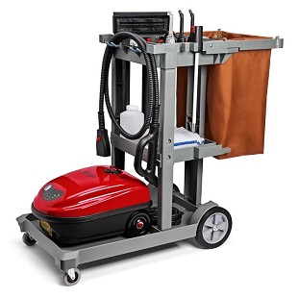
Owner of Two of the South’s Leading Properties Chooses Advanced Vapor Technologies’ MondoVap 2400® Steam Vapor Systems for Cleaning & Disinfecting
AIKEN, S.C.—At Aiken, South Carolina’s The Willcox and Lake Toxaway, North Carolina’s The Greystone Inn—lauded for their southern hospitality by readers of the world’s leading travel publications—owner Shannon Ellis is using MondoVap® 2400 machines from Advanced Vapor Technologies to keep the properties sparkling clean and disinfected with just one ingredient: ordinary tap water.
“There is nothing safer than working with water rather than chemicals,” says Kerry Rigg, an OSHA instructor who visited The Willcox and The Greystone Inn a year ago to train staff on the MondoVap®.
“When COVID-19 hit, I began researching new ways to clean and sanitize our hotels,” Ellis said. “We had already implemented best practice sanitizing protocols. I was interested in how the TANCS® technology with the MondoVap® 2400 allowed you to clean and disinfect within seven seconds with no residual product left behind. I also liked that it was sustainable—no chemicals and no problem for people with allergies.”
Advanced Vapor Technologies’ proprietary Thermal Accelerated Nano Crystal Sanitation (TANCS®) technology is a factory-installed internal component that utilizes nanotechnology and minerals—the same minerals found in tap water—to kill microscopic organic matter such as germs, bacteria, and viruses in mere seconds. According to a study published in the American Journal of Infection Control by researchers in the School of Environmental Health at the University of Michigan, TANCS®-equipped steam vapor systems achieve a greater kill rate in 3 seconds than a 20-minute exposure to bleach. Because of this peer-reviewed study and others, the number EPA Est. No. 82121-WA-01 was assigned to Advanced Vapor Technologies and is proudly displayed on each MondoVap®. The number tells you at a glance that the MondoVap® qualifies as a disinfection device for the EPA. Only Advanced Vapor Technologies steam vapor systems have TANCS®.
MondoVap® 2400
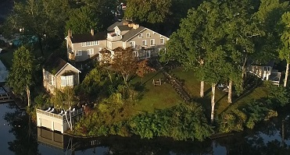
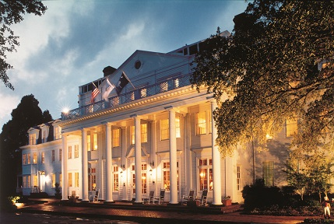
‘Superior to Chemical Products’
“Our housekeeping department uses the MondoVap® 2400,” Ellis says. “Our restaurant team uses it to clean stains made by guests on upholstered chairs and rugs. Staff like how portable it is and how well it cleans. The attachments are great at allowing you to get into hard-to-get places like tight edges around faucets and the base of toilets. It is amazing at cleaning tile and glass doors. It’s superior to the chemical products at cleaning and sanitizing many surfaces.”
MondoVap® 2400 tools and accessories range from extension wands to a wide range of brushes to turbo nozzles.
Ellis says the machines’ ability to keep viruses like COVID-19 at bay was essential to the decision to purchase the machines.
“The challenge the hotel industry faces in the era of the coronavirus is that while properly-used chemical disinfectants kill undesirable microbes, these products are pesticides that present health and environmental hazards, require that a surface first be cleaned before application, must be left on 10 minutes or more (which isn’t possible with vertical surfaces), and leave a residue that must be rinsed off so it does not breed more bacteria,” says Wayne Delfino, whose family owns Advanced Vapor Technologies. “The MondoVap® gives hotel housekeepers a way to disinfect surfaces in one step while keeping guests and staff safe.”
Ellis touts many of the green initiatives in place at The Willcox in a document on that property’s website. It is a sustainability journey that began at the hotel in 2010 with South Carolina Green Hospitality Alliance certification. Included in the document is the following: “We use the MondoVap 2400® Vapor Steam cleaner and disinfectant in all areas of the hotel and as our green alternative for guests who prefer chemical free cleaning and disinfecting.” The MondoVap® is also cited similarly on The Greystone Inn website.
Ellis emphasized that of all the cleaning products used at her two hotels since the onset of COVID-19, the most innovative is the MondoVap® 2400.
About Advanced Vapor Technologies:
The Greystone Inn
The Willcox

Advanced Vapor Technologies (Advap) was founded by a critical need to address the adverse health effects and lengthy contact times of chemical disinfectants. We saw a void in the disinfection field and established the goal of harnessing the power of steam to destroy germs, bacteria, and viruses in mere seconds while leaving behind no residue for existing and new forms of pathogens to live like chemical disinfectants do. Through 25 years of pioneering steam vapor systems and continually improving them, we developed our proprietary technology: TANCS® (Thermal Accelerated Nano Crystal Sanitation), the technology now at the heart of all Advap steam vapor systems. Using only ordinary tap water, steam vapor systems like the MondoVap® 2400 combine TANCS® technology at the molecular level with superheated dry steam at the surface to disinfect hotel guestrooms, kitchens, and lobbies thousands of times better than chemical disinfectants must meet to qualify as EPA registered. The results are redefining the game. Call (800) 997-6584 for more information.

